The design of the school

[Northern District Times](http://www.dailytelegraph.com.au/newslocal/northern-district-times)

http://www.dailytelegraph.com.au/newslocal/northern-district-times/smalls-road-public-school-at-ryde-has-circular-design/news-story/39136f6ccf6f1dd30bf2cc35b26d60cb

**Smalls Road Public School at Ryde has circular design**

Steven Deare, Northern District Times

May 2, 2017 2:59pm

•

A CIRCULAR design and two playing fields will be among the features of the new Smalls Road Public School at Ryde when it opens in 2020.

The first artist’s impressions of the school, which will accommodate 1000 students, have been released along with more details.

Classrooms and facilities will be spread across three storeys, and form an arc around a central courtyard.

The courtyard will be the “heart” of the school, according to planners.

The Department of Education site was home to Ryde High School until it closed in 1986. The old buildings will be demolished to make way for the new ones.

The new facilities will include after school care, indoor play spaces, a covered outdoor learning area and library.

Artist's impression of the planned Smalls Road Public School at Ryde

Pedestrian entry would be via Smalls Rd, as well as Lavarack St.

The state government has costed the project at $30 million.

It is set to provide welcome relief for families of current and future public school students, and teachers.

The number of students attending the 24 public primary schools in the northern district grew by four per cent (531 students) this year to 13,242.

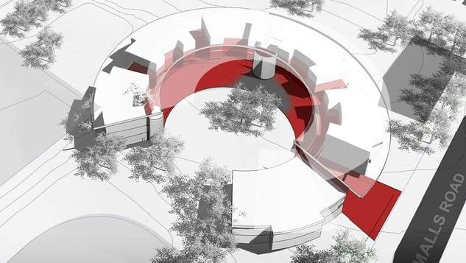

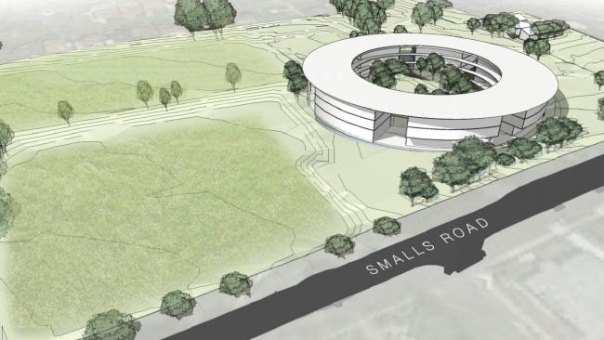

The Northern District Times has campaigned for a new school since May 2015, highlighting population pressures and that many schools have resorted to demountables to provide more classrooms, often at the expense of playground space.

Later that year, former Education Minister Adrian Piccoli promised a school would be built.

In planning documents, the state government said Ryde Council will provide a synthetic surface for one of the playing fields, which will be used by students and the public.

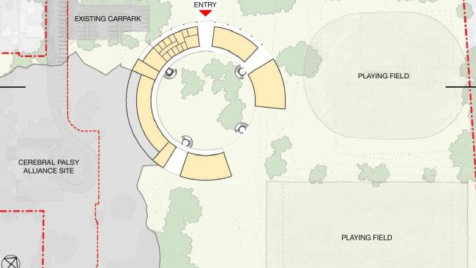

Diagram of the planned Smalls Road Public School at Ryde

The government also required that sports groups who currently use the fields be able to continue while the school is built.

The government has previously said construction will allow the option of a secondary school to be built on the site later.

The government is still to lodge a development application with planning authorities, which will require community consultation on all aspects.

The Smalls Road facility is one of several new schools being planned to cope with population pressures. Others include a primary school at Kellyville, and a high school at Surry Hills.

The government’s new education infrastructure unit will oversee the creation of the Ryde school.

Education Minister Rob Stokes last week announced the unit will be formed to ensure there is enough schools and classrooms for a significant increase in students over the next 15 years.