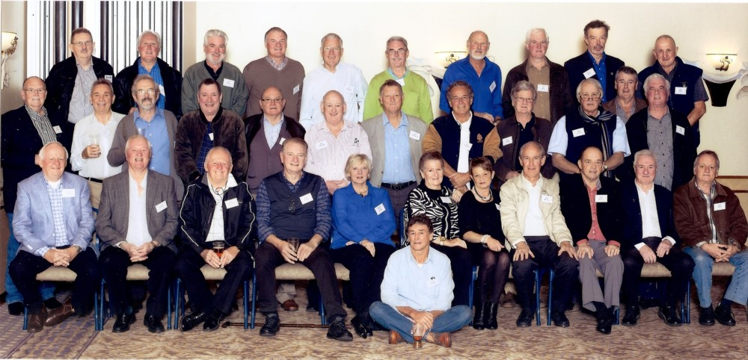
Peter Herd
Ross Howarth
John Crowley
Tony Rumble
Terry Theakstone
Ross Chalcraft
Peter Cunningham
Ian Herd
Richard Walton
Barry Herbert
Ian Southwell
Ron Brown
David Tonkin
Brian Yeo
John McBride
Alan Arnott
Paul Anderson

